Programs in Sciences and Humanities

Programs in Sciences and Humanities
FAST-NUCES

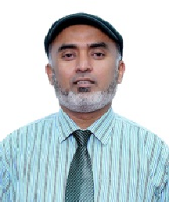

Dean's Message
I t i s w ith gre dt p ie ds u re an d enthusiasm thdt I extend d warm welcome to you on behalf of the Faculty of Sciences and Humanities dt National University of Computer dnd Emerging Sciences. As the Dedn of th is estee med lac u lt , I dM delighted to introduce you to the myridd of opportunities dwaiting you within our academ ie com munity. At th e Fac u lty of Sci en ces and Humanities, we pride ourselves on fo ste r i ng a d yn am i c ie a rn i n g environment where curiosity thrives, and innovation flourishes. Whether your passion lies in exploring the mysteries of the universe through Math em ati cs, or un raveli ng th e nuances of Applied Linguistics, our diverse range of programs offers something for everyone. It sounds pe rti n en t to men ti on th at th e D e p a rt m e n t oI S c i e n c e s a n d Humanities, Lahore Campus, enjoys the credit to produce the first ever PhD in Mathematics dnd has so far produced 35 PhD's who dre serving in the nook and corner of the country dnd dbroad in their forte. To add to this, Ldhore CampuS dlso bdgs the h o n o u r to h d V e s u C c e S Sfu l ly launched M Phil Applied Linguistics and have produced unnumbered g r d d u a te s w i t h s p e c i a I ty i n Computational Linguistics, dnd they are either serving in various fields or h a v e e a r n e d i n t e r n a t i o n a I scholarship and are pursuing their h i g h e r ed u ca t i o n i n g Io b a I ly renowned universities abroad.
Here, you will I nd dedicated faculty
members who are not only experts in I h e i r fi e I d s b u t a I s o d e e p I y c o m m i tte d to n u rt u r i ng yo u r

i n t e I I e c t u d I g r o w t h d n d development. Our faculty members are not just educdtors; they are mentors, collaborators, and catalysts for your dcademic success. They dre here to guide you, inspire you, dnd chdllenge you to redch new heights Of dcddemic excellence.
AS d Stu d ent in th e Fac u tty of Sciences and HUMdn ÏtÎ9S, OU WÎ tt h ave access to state-of-th e -art facilities, cutting-edge research op portu n ities, and a su p portive community of peers who share your passion for knowledge. Whether you a s p i re to p u rs u e a ca re e r i n academia, industry, or beyond, our co mp re he ns ive cur ri cu lu m and experiential learning opportunities wi tI equi p yo u with th e s ki I ts, knowledge, and confidence to thrive i n to d a y' s rd p i d ty e v o t v i n g world.Beyond the ctassroom, our fa c u I t y e n c o u r a g e s a c t i v e en gage ment i n extrac u r r i cu la r activities, student organisations, and c o m m u n i ty i n i ti ati ve s. T h e s e experiences not only enrich your äcddemic journey but dlSO help you d eve lo p e s se n t i d I le dd e rs h i p, communication, dnd teamwork skills t h a t a r e i n V d t U d b 19 i n d n y professional setting. Moreover, our commitment to diversity, equity, and inclusion ensures that every student fe e I s v a I u e d , r e s p e che d , a n d emp owe re d to co ntri bu te th eir unique perspectives to our vibrant academic comm unity. We believe that diversity is not only a source of stre n gth but also essentia t for driving innovation and solving the complex challenges facing our world
today.

Dr. Akhlaq Ahmad Bhatti
Professor and Dean (Sciences and Humanities) PhD (Path), GCU, La hore (2007)
PhD Approved Supervisor
MPhif (Math), GCU, La hore (2003) MSc (Path), GCU, La hore (2001)

As you em bdFk on this exciting journey of exptordtion and discovery, know that the Facu Qty of Sciences and Humanities is here to support you every step of the way. Whether you have questions about our programs, need assistance with the admissions process, or si mply want to learn more about what makes our faculty special, please don't hesitate to reach out to us.
On behalf of the entire faculty and staff, I wish you all the best in your aca d e m i c en d e avo rs. We to o k forward to welcoming you to our co mmun ity and w itn essi ng th e inered ible contributions you will undoubtedly make during your time with us.

Prospectus 2025

FAST—NUCES Programs in Sciences and Humanities

MS Admission Test, Eligibility and Selection Criteria

Degree Master of Science (Applied Linguistics)

Admission Test
Applicant must select only one out of the
three ddmission test options
FAST-NUCES
GRE GeneraI
NTS GAT- B General


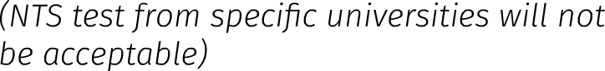
Eligibility
Mdster Degree in English Ldngudge Minim u m 55% Pdf ks or CC PA Of dt fedst
Teaching (ELT), or Teaching English as a 2.00 on a scale of 4.00 Second Language (TESL) or English
Lite rdture (EL) Or d reldted d iscipline dfter
16 years of education
Selection Criteria
1
2
Weightdge of Ad m ission Test md rks
Weightage of past academic record (4 year Bache for or 2 year Bdchelor/2 yed r Mdster)
50%
50%

Degree |  | Master of Science (Mathematics)
Admission Test | Applicdnt must select only one out of the | FAST-NUCES
 | three ad mission test options | GRE GeneraI
 |  | NTS GAT- B Generdl
 |  | (NTS test[rom specific universities will not
 |  | De acceptaD/e/
Eligibility | Degree in d relevdnt subject or d reldted discipline earned from a recognized | Minim u m 55% Pdf ks or CC PA Of dt fedst  2.00 on a scale of 4.00
 | University dfter 16 years of ed UCdtion
Selection Criteria | 1 Weightage of Ad mission Test mdrks | 50%
 | 2 Weightage of past academic record | 50%
 | (4 year Bache for or 2 year
 | Bdchelor/2 yed r Mdster)

Note: All documents/transcripts will be checked at the time of ad mission. Any incorrect/false information submitted by the applicant or any attempt to hide information will lead to disqualification of the candidate for ad mission.

Prospectus 2025

Programs in Sciences and Humanities
FAST-NUCES

Master of Science (Applied Linguistics)

Program Mission
There is an ever — growing demdnd of trained English teachers. Colleges, universities, dnd language schOOl dlv need qudlified English tedchers. English has now become more than a mare language. It is a bridge across borders dnd cultures, and a source of unity in a rapidly evolving world. This program shall endble students to learn how linguistic analysis can be used in practice in the Vdst arena of Language with specie allegations in Co m p u te r As s i ste d L a n gu d ge Learn i ng (CALL), Co mpu tati onaI Linguistics (CL), English Language Teachi ng (ELT), and En glish for Spe cifi c Pu rp o ses ( ES P). T h i s program inculcates specialized skills to effectively perform teaching of En glish langu age. This p rogram integrdtes Ldnguage and computing skills.
Career Opportunities
- To prod uce qualified teaching
resource.
- To integrate ICT (Information dnd Communication Technologies) in Teaching of English Language.
- To develop co lla bo rati ve r-learning resources for teaching.
- To encourage teachers to be critically engaged in advdnced research in English tangu dge tedching and learning.

Award of Degree
For the award of Master of Science (Ap pIi ed Li n gu istics) d egre e, a student must have:
- Passed courses totaling at least
30 ered it hours, including all those courses which have been specified as core courses.
- Obtained a CGPA of at least2.50.

Tentative Study Plan
Master of Science (Applied Linguistics)

Code Title Cr.Hrs
Semester-I
SS5001 Computing Assisted Language Learning | 3 | 0
SS5002 Fundamentals of Language and Linguistics
SS5003 Computational Linguistics
Total
Semester-II
555005 Research Methodology | 3 | 0
SSXXXX Specialist Module—I
SXXXX Elective-I
Total
Semester-III
SS5091 Thesis-I
SSxxxx Specialist Module-II
Total
Semester-IV
555092 Thesis—II | 0 | 3
SSxxxx Elective-II
Total
G. Total
Registration in 'MSThesis-I'shallbe allowed provided the student has
- Earned dt least 18 CH
- Passed the 'Research Methodology course'AND
- CGPA is equal to or more than 2.50
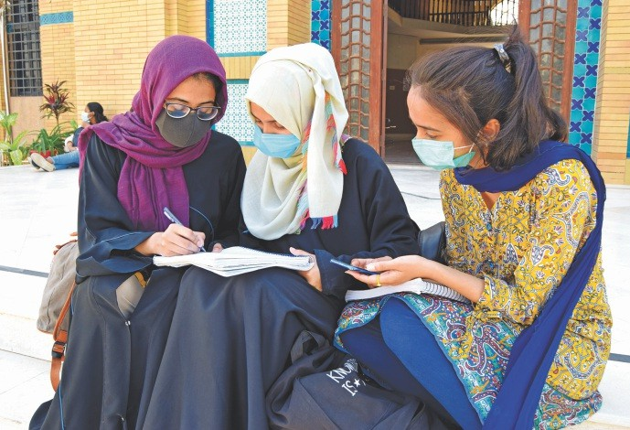


Prospectus 2025

FAST- N U C E S

Master of Science (Mathematics)
Programs in Sciences and Humanities

Program Mission
The Mdster of Science (Mathematics) p r o g r a m a t FA ST - N U C E S i n committed to provide an excellent major for students, whose career
§Odts are teaching, immediate entry into allied arends or pursuit of a h i g h e r r e s e a r c h d e g r e e i n mat hem ati cs. This p rogram wi II e n d b ie s t u d e n ts to d e v e I o p quantitative dnd abst5ract reasoning b y U S i N § M dt h e M a t i cs a s d n analyticaI too l. I n fulfi lli ng this mission, the department has created a n e n v i r o n m e n t to r q u a l i ty i n str u cti on to al I st uden ts i n Mathematics courses and nurturing a pteasdnt and constructive facuQty student interface.

Career Opportunities
- To integrate relevant knowledge and pose new questions across a range of p ure and ap plied mathematics.
- To p rovide a background of mathematics for research and development.
- To learn novel mathematical concepts, methods and tools for application in the applied fields.
- To co nstru ct, an alyse an d interpret mathematical models for real-life problems, drawing from a wide range of areas of mathematics.
- T o b r i d g e t h e g a p f o r m a t h e m a t i c i a n s b e tw e e n financial academic institutions.
Award of Degree
For the award of Master of Science (Mathematic) degree, a student must have:
- Passed courses totaling at least
31 credit hours, including four core courses.
- Obtained a CGPA of at least2.50.


Prospectus 2025

Tentative Study Plan
Master of Science (mathematics)

Code |  | Title | Cr.Hrs
Semester-I
MT | Core Course- I
MT | Core Course—! I
MT | Elective-I
MT | Elective-II
Total
Semester-11
MT | Core Course— III
MT | Core Course- IV
MT | Elective— III
MT | Elective— IV
Total
Semester-III
555011 | Research Methodology
MT | MS Thesis-I
Total
Semester-IV
MT | MS Thesis—II
Total
G. Total
Registration in 'MSThesis-I' shall be allowed provided the student has
- Earned at least 15 CH
- PdSSPd the 'Research Methodology course' AND
- CGPA is equal to or more than 2.50
A student has the option to pursue MS either by undertaking a 6 credit hour MS Thesis, or by taking a 3 credit-hour research Survey Plus one taught course.
